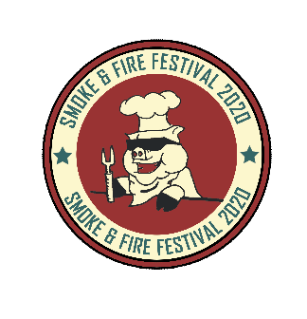
14th - 16th AUG 2020
FOOD STALL APPLICATION ONLY
HOT FOOD STAND | 2 DAY FEES £ |  | FEE TOTAL £
HOT FOOD STAND | £395.00
6FT TRESTLE TABLE | £15.00 Each | Number required ( )
EXTRA CHAIRS | £3.00 Each | Number required ( )

BOOKING FOR ELECTRICS  Please book on this form for all electrical supply.  If in doubt, ask | All your electrical equipment must be PAT tested | Please indicate requirements and add sum to your booking
*Warning if you overload the system we will charge £40 per call out. Ask for guidance if not sure . | COST | NUMBER
16 AMP Single phase connectors* | £55 |  | £
32 AMP Single phase connectors* | £65 |  | £
Overnight supply | £40 |  | £
*Any stands requiring electricity must bring their own certified extension leads (minimum of 10 mtrs long

Please do not send payment with this application we will invoice you once your application has been accepted
A refundable £150 cash litter, damages and impact bond is payable on arrival (See T&Cs) for details
We are Non-profit organisation, all profits will be donated to our chosen charity for 2020
Trading Name
…………………………………………………………………………………………………………………………………………………………………………… (Please use this name in all correspondence)
Product Description ……………………………………………………………………………………………………………………………………………………………………………
*Contact TelNo(s)……………………………………..……………………*Mobilenumber………………………………………………………………………...
Website ………………..……………………..…………………* Email Address (please print)……………………………………………………
*Address (inc Postcode) ……………………………………………………………………………………………….……………………………………………………………………………
*Name (please print) ……………………………………………………… * Signed………………………………………....
* Required to be completed
(By signing, you acknowledge that you have read, understood and agree to abide by the Terms & Conditions pages: 7 to 12)

Smoke & Fire Festival Food Stall Application 2020
Basic Information

Trade Details
- Please describe the food you wish to sell from your stall. (100 words maximum)
____________________________________________________________________________________________________________________________________________________________________________________________________________________________________________________________________________________________________________________________________________________________________________________________

- Dietary requirements: Do you cater for any specific dietary requirements (i.e. Vegan/gluten-free/halal etc.)?

Yes _______ No_______

- The Smoke & Fire Sample - Family Feast ticket: It’s important for us that our visitors are able to try as many different types of food types and styles as possible.

In order to do this and as part of being allowed to trade we expect ALL food traders to offer a sample size dishes of one of the main meals offered on their menu. We will be promoting and offer an advance purchase meal ticket for £20.00 which will entitle the owner to 4 x sample meals. Each token is worth one Sample meal of their choice from those participating traders. For each token (you the trader will be paid £4.00) by the organisers based on the number of tokens collected and returned in aid of Air Ambulance. The Smoke & Fire Food meal ticket will be promoted via the website and on all printed media,

Please tick the box to indicate that you have read agree to the above
- Please tell us about anything special or unique your stall would bring to the Festival (200 ______________________________________________________________________________________________________________________________________________________________________________________________________________________________________________________
- Which Local Authority you are registered with__________________________________________
All Food traders must be registered with their own Local Authority.

- Council Food Hygiene Star Rating (Scores on the Doors) *

Please note, only traders with a rating of 4 or above will be considered.

1
2
3
4
5

- Personal Food Hygiene Certificate (must be level 2 or above)?
Yes
No
- Health and Safety policy / Company Safety Statement
If you have 5 or more employees
Yes
No

- List the items on your menu and the prices you will be charging during the festival including drinks (if any)
______________________________________________________________________________________________________________________________________________________________________________________________________________________________________________________________________________________________________________________________________________________________________________________________________________________________________________________________________________________________________________________________________________________________________________________________

- How many staff will you have with you?
_______________________________________

Pitch Width in metres ______________________________________
The total width in metres you require including any guy ropes, menu boards, towing hooks etc.

Pitch Depth in Metres______________________________________

The total depth in metres you require INCLUDING YOUR STALL. This must include space for any essential onsite vehicles, caravans, camping and storage. Space is limited so be realistic in your requirements. We cannot guarantee the requested space will be available, if your application is successful, all your requirements would need to fit within the allocated pitch size.
Please be aware that camping may will not be directly behind your stall however should be within the allocated event area. We reserve the right to allocate camping as appropriate according to site Health and Safety requirements.

Number of passes required______________________ (Anybody aged 13 or over at the time of the Festival will require a pass)

Vehicle Requirements
Number of essential onsite vehicles_________________________________________
Onsite vehicles are parked behind your stall within your pitch requirement, they are not able to be moved until 19:30PM 16TH August 2020. These vehicles must be diesel (no petrol vehicles to stay onsite)

Number of short stays vehicles_______________________________________________
Short stay vehicle passes allow traders with staff passes to drive on to the site for the purpose of unloading before parking in the trader’s cars parks.

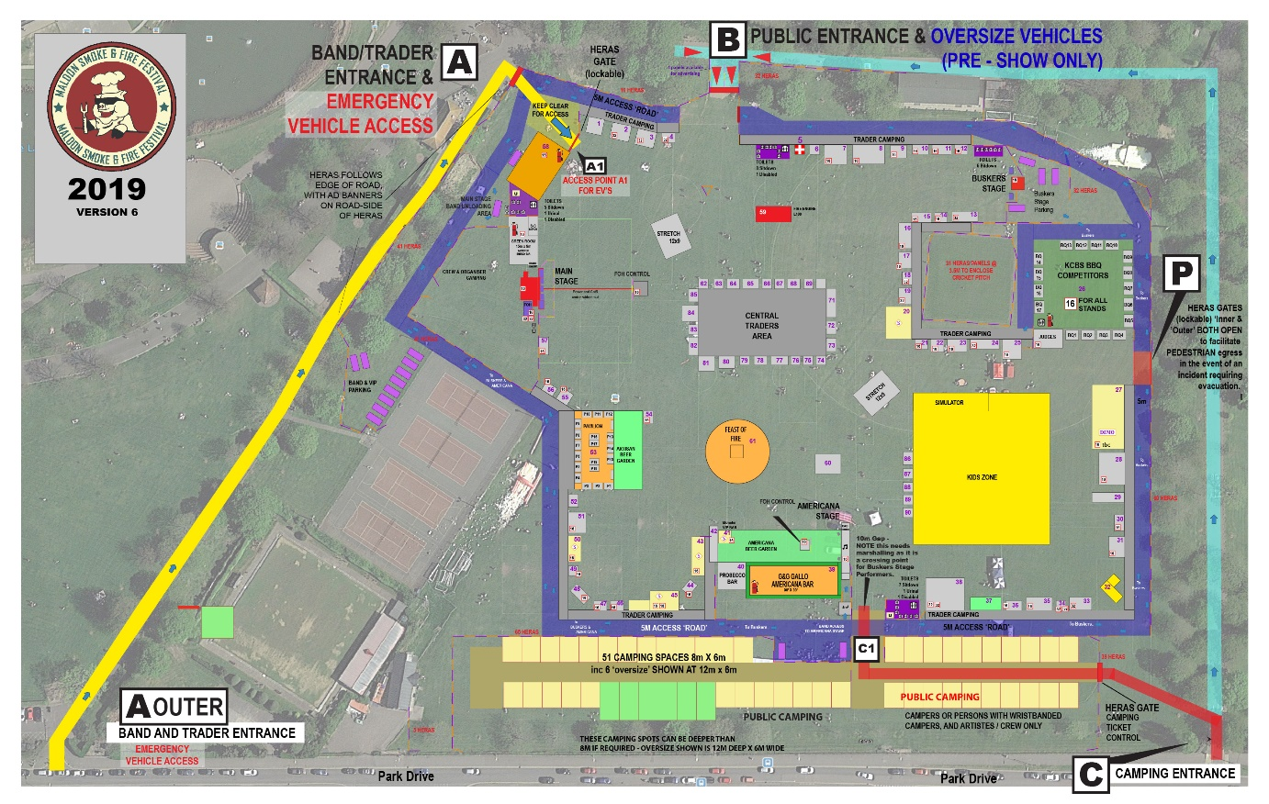
Site plan example of 2019
Fire risk assessment must be completed by all stall holders

Fire Risk Assessment
Exhibitors
2020
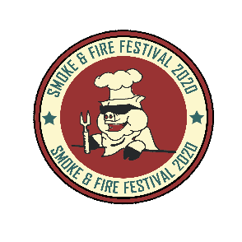

Trading Name

Contact No.

In order to comply with relevant fire safety legislation you MUST complete a Fire Risk Assessment of your stall or unit. This includes if you have a table inside our Marquee (TBA).
The Risk Assessment needs to identify the fire hazards and persons at risk; you must endeavor to remove or reduce these risks and protect people from fire. Failure to comply with this requirement will result in you being removed from the site.
You must be able to answer YES or N/A to the following questions.

 | YES | NO | N/A
1. Make sure there are adequate exits provided for the numbers of persons within your unit or stall/table and that the exits unobstructed at all times the stall is in use?
2. Do you have an adequate number of fire extinguishers/fire blankets available on your stall if applicable?
3. Has the fire-fighting equipment been tested within the last 12 months and is the staff instructed on how to use it? (This may be checked by our stewards on the day)
4. Have your staff been made aware of what to do should an incident occur, how to raise the alarm, evacuate the unit, and exit locations? (This is in our T+C)
5. Have you identified all ignition sources and ensured that they are kept away from all flammable materials?
6. Are the structure, roofing, walls and fittings of your stall or unit flame retardant?
(This may be checked by our stewards on the day)
7. Do you have sufficient bins for refuse? Is all refuse kept away from your unit and any sources of ignition?
8. Are you aware that petrol generators are not permitted on site without a separate risk assessment?

If you use LPG, Gas – please contact the show office
Stallholder/
Person Responsible: ………………………………………………………………………………………
Signature Print Name Date

PLEASE NOTE
THIS DOCUMENT DOES NOT PRECLUDE YOU FROM POSSIBLE PROSECUTION OR REMOVAL FROM THE SITE BY THE ORGANISERS, SHOULD A SUBSEQUENT INSPECTION REVEAL UNSATISFACTORY STANDARDS.
_____________________________________________________________
Please complete and return the items below

Tick Copy of valid Public Liability Insurance
Tick Fire Risk Assessment
Tick Any other relevant certification (Hygiene certificate etc)

EMAIL YOUR COMPLETED BOOKING FORM

Traders@Smokeandfirefestival.com
All applications to trade during the event will be accessed by the event organisers and you will be notified if your application has been successful within 14 days of receipt of your application

Late entries may be accepted subject to availability and WILL incur an additional charge.

Lastly as the organisers our aim to offer as wide diversity of stalls as possible and to ensure that you as traders have the best opportunity to promote and sell your products. If successful in your application, we would ask that you help promote the festival via your own business website and social media network feeds.

All traders will be listed via the Smoke & Fire Festival website

We very much look forward to welcoming you to the event, should you have any questions please do not hesitate to contact the organisers at info@smokeandfirefestival.com or call
Tel: +44(0)7843 21719
Friday 18:30 – 22:30 - Saturday 17th 10:00 – 20.30 & Sunday 18th August 10:00 -18:30

Terms and Conditions
This copy of our standard terms and conditions is intended to apply across the different types of exhibitors and attractions that attend
- No Sub-Letting
Trade Stand space shall be for the sole and exclusive use of the trader applicant and no sub-letting of space is permitted.

- Stand Preparation and site clearance

VEHICLES WILL NOT BE PERMITTED ON THE PARK GROUND AFTER 10.00 ON THE FESTIVAL DAYS. The Festival area will be open for exhibitor’s equipment from Thursday 13th August between the hours of 9:30am and 16:30 after which the gates will be closed and then the gates will open from 07.30am on the Friday and close at 16:00 opening again to the public at 18:30 Trades will be issued an arrival time for the Thursday/ Friday/ Saturday. (All hot food traders are required to be on site by Friday). Any equipment left on the Festival area will remain at the sole risk of the exhibitor. The Festival ground will be manned on the night of the 14th August, but no responsibility whatsoever can be held against Smoke & Fire Festival and any trader wishing to stay on the Festival the night of the 13th August can do so with the permission of Smoke & Fire Festival .

During load and break down. All Personnel must wear a high visibility vest during set up and break down and you must adhere to The Working at Height Regulations at all times. Please also ensure staff wear appropriate clothing and closed toe shoes or boots.

No smoking is permitted in or within a 3-metre radius of any Pitch.

No guarantee can be given as to the location of any Trade Stand. Any exhibitor who breaks the soil of the Festival ground for the purpose of fixing any exhibit must restore as found. Exhibitors will be held responsible for any damage done to the property of the Festival Organisers, its contractors and other exhibitors.

*All rubbish and equipment must be binned and removed before leaving the Festival site . Failing this, the Festival Organisers will perform the removal and any necessary work or reparation and the stall holder will forfeit their Litter Bond (See section 18) failure to pay will mean that the exhibitor will be banned from any future Smoke and Fire Festival events.

- Liability and Indemnification of the Festival
The Festival Organisers, its officers, servants, agents and employees will not be responsible for, or accountable to, any person whatsoever for any damage or loss, however caused, to the property of any such person that may occur whilst upon the Festival or Car Parks or whilst entering or leaving the same.

The Festival Organisers, its officers, servants, agents and employees will not be responsible under any circumstances whatsoever for any accident, loss or damage, however caused, that may occur to, or be caused by any person or to or by any animal, vehicle or equipment exhibited or brought onto the Festival ground or Car Parks. Each exhibitor or competitor shall accept sole responsibility for any such accident, loss or damage concerning him and shall hold the Festival Organisers, its officers, servants, agents and employees harmless and indemnify them against any legal proceedings arising there from.
Each exhibitor and competitor must have adequate public liability insurance cover.

- Admission and Vehicle Passes
Exhibitors who have paid their appropriate fees will be sent at least seven days before the Festival your exhibitors Festival arrival instructions and car park pass which will state your entry gate.

Additional site passes may be obtained from the Secretary strictly on a arranged basis, and these will be valid on the day of the Festival. Passes will be required for vehicles prior to the Festival. These must be requested on application and will be issued on acceptance. Vehicles without a pass will not be allowed entry to the Festival Area.

5. Vehicles on Promenade Festival ground
To comply with Health and Safety requirements, unless specifically authorised by an official, vehicles will not be permitted on the event ground after 09.00 on the Festival days. No vehicles may be moved about the Festival area between the hours of 9:30am and 30 minutes after the official festival closing time (Festival closing times: Saturday 17th: 20.30 Sunday 18th 18.30). There is a 5mph speed limit in force at all times. If vehicle towing is required, then The Smoke & Fire Festival accept no responsibility whatsoever if any damage is caused. Wristbands identifying staff will be issued to you on arrival. If you have other staff, please give us a list and we will issue a wristband for each staff member.

6. Duration
All Stands MUST be ready for trading at 10.00 and MUST be kept open until official Festival closing times ( 14thFriday 22:30 -Saturday 15thth August 20.30, Sunday 16th August 18.30)

7. Nuisance
The use of loudspeakers is prohibited unless written permission has been obtained by the Festival organisers and traders must not create noise or smell likely to cause nuisance, damage or offence to adjoining stand-holders, visitors of the Promenade Park or at the Festival.

8. “Cheap Jacks”
Vendors of low quality trinkets, plastic toys and other articles of a “cheap jack” nature are not permitted to exhibit and the selling of goods by auction, shouting or any other annoying behaviour is forbidden.

9. Certificates Foodstuff
NO READILY EDIBLE FOODSTUFFS MAY BE SOLD ON THE GROUND OTHER THAN BY THE OFFICIAL CATERER OR BY A NOMINATED TRADE STAND HOLDER WHO MUST FIRST OBTAIN WRITTEN PERMISSION OF THE FESTIVAL ORGANISERS TO DO SO. They will be required to comply with the Food Act 1984 and Environmental Protection Act 1985. A Written Food Safety Management Procedures are required by law. These must be available for inspection at all times.
Any exhibitor selling alcoholic beverages or foodstuffs containing alcohol must have an appropriate licence to do so.

10. Fire Precautions
All Traders must take proper precautions against fire. Including display of notices to prohibit smoking in the immediate vicinity of any inflammable material or inside stands/tents. All traders with inflammable material shall provide fire extinguishers bearing current proof of test designed to deal with the risk involved and of a type approved by the local Fire Authority. The above stands must provide at least two buckets to be kept filled with sand/water throughout the period of the Festival. All tents are to be fire retardant. No naked flames are permitted on any stand without agreed risk assessment FAILURE TO COMPLY WITH THIS REGULATION WILL RESULT IN CLOSURE OF THE STAND.

- Statutory Requirements
Stand holders and exhibitors must comply with all requirements for the Health & Safety at Work Act 1974, and Food Act 1984, Public Liability Insurance, the Food and Environment Protection Act 1985, Fire Precautions Act 1971, and any other statutory provisions and regulations applicable to their particular stand or exhibition.

- Gas
All stand-holders must ensure their gas appliances have been recently examined and tested by a competent person and labelled to indicate the examiners name and the date of the examination. The organisers will not allow any appliance to be used unless this has been done.

- Electricity
Electricity is NOT available on the Festival site unless it has been pre-booked. Proof of electrical safety must be available for all electrical equipment used. Fully competent electricians must be employed for all 240V electrical work on the Festival ground. 110V equipment is preferred. If you have booked electricity, we aim to have you switched on by 10am on Saturday but please be patient as it is a complicated procedure. Our electrician will get to you in time. Security will be onsite overnight. You may leave your stall set up.

- Generators
PETROL GENERATORS WILL NOT BE ALLOWED TO BE USED ON SITE.
Stand-holders may use diesel generators, but they must be properly silenced to the extent that no nuisance is caused to other exhibitors. It is essential to use a quiet type of generator, or provide a baffle to cut down noise. The Festival Organisers will shut down any noisy generator.
No generators will be allowed in any Marquees, Tents and stand-holders should notify the Festival Organisers with their application of electricity if required.

- Use of Trade Stand
The display of any sign, placard, notice, distribution of leaflets or any other activity limited to any trade stand or business may only take place on an exhibitor’s own stand and is expressly prohibited elsewhere.

- Competitions, prize draws, raffles etc
Apart from Charity stands issued with a permit, NO stand-holder will be permitted to levy a charge for any competition held on the stand. No promotion of any competition/prize draw shall be carried on outside of the booked stand space.
The Event Organisers reserves the right at its sole discretion to stop any competition which it considers unsuitable/unsafe.

- Environmental Obligations:
You agree to implement best available environmental practices and comply with any environmental policies supplied to You by SAFF or by the Event Organiser or Venue Owner, ensuring that:
- Packaging on all goods sold by You is minimised and recycled and that biodegradable packaging and cutlery is used where reasonably practicable. In particular, we ask all Traders to eliminate single use plastic (including cutlery) and single use straws where reasonably practicable;
- You MUST dispose of any grey wastewater in an appropriate manner and in accordance with the Event disposal methods;
- You MUST remove all waste oil and gas canisters both empty and full off the Event Site;
- You MUST remove any rubbish and waste generated by You that does not reasonably relate to the provision of the Services from the Event Site;
- You MUST submit to any inspection by Environmental Health officers at the Event, providing all relevant paperwork and information as required;
- You do not put stakes into the ground without written permission from Us;
- You respect the Event Site and its surroundings.
- You adhere to any additional environmental obligations and guidance as provided in the Trader Pack, the Agreement or any other communications.

- Removal of litter and waste

You agree to pay a refundable Bond, which will cover litter, damage & impact to Us. This will be paid in cash, on arrival at the Event Site. The amount will be confirmed to You in writing in advance of the Event. This bond can only be returned to you:
a. by Smoke and Fire Festival (SAFF) ; and
b. whilst You are still on the Event Site before Your departure from the Event; and
c. after inspection of Your Pitch by ; and
d. confirmation from SAFF that You have left Your Pitch in the condition that You found it, as set out in Section 2 above (to include but not limited to the removal of all equipment, refrigeration, gas bottles, oil and/or litter).

Any official of the Festival Organisers shall have power to expel from the Festival ground any exhibitor or his representatives failing to comply with these Rules and By-Laws within these terms and conditions.

- Disputes
Any disputes arising from or out of these Rules and By-Laws shall be submitted in writing to the Festival Organisers for adjudication and the decision of the Festival Organisers shall be final and binding on all parties.

- Health, Safety & Welfare

All persons involved shall comply with the Health & Safety Policy which is available upon request. This will include supplying such information as is requested by, and any additional requirements of, the Festival Organisers.

- Accidents, Near Misses & Hazards

On the event days, first aid support will be available on their stand or can be summoned by stewards via radio. On Friday 16th August you are required to make your own arrangements. If you have qualified persons who would be prepared to help with others, please tell us. A formal book is kept in the Festival Office to record accidents, near misses and hazards. Notify all to an official in the Festival Office.

22.1 Vulnerable Persons
You are responsible for your own people and should make arrangements for nursing mothers and pregnant women. Disabled persons and children are to be adequately assisted and supervised by you as necessary at all times.

22.2 In the Case of Evacuation
1. |  | Before leaving, make a quick visual check of your stall. Is there anything unusual, or anything you don’t recognise as your property?
 |  | IF YOU FIND SOMETHING, DO NOT TOUCH, REMEMBER THE DETAILS, INFORM AN OFFICIAL IN THE FESTIVAL OFFICE BY THE MAIN STAGE.
2. |  | Can your cash receipts be removed easily from the stall? If so, take them with you, if not, secure them and leave. Do not attempt to remove your property/vehicles unless asked or directed to do so by police.
3. |  | Ensure all persons are accounted for to the best of your ability. Leave the area or Promenade as directed by the Stewards/Police.
 |  | Do not attempt to return to the Festival ground unless cleared to do so by the Police.
4. |  | DO NOT PANIC, WALK QUICKLY, DO NOT RUN

23. Dogs
Dogs are welcome on the festival site BUT must be kept on a lead at all times when in the designated festival area
.
24. Photography
Any photographs taken by festival officials on the day are the ownership of the Smoke & Fire Festival. Smoke & Fire Festival reserve the right to use the photographs for marketing purposes.

25. Marquees/Gazebos

Smoke & Fire Festival cannot guarantee that any marquees supplied are waterproof and therefore cannot be held responsible if products get water damage. It is the stall holder’s responsibility to make sure their Marquees/Gazebo’s are well anchored to the ground and not to cause damage/annoyance to other exhibitors

26.` Camping
Please note we have a no naked flame policy at the festival other than in areas approved by the organisers such as the BBQ competition team areas. Fires flare and fireworks, Chinese’s lanterns etc are forbidden and will be extinguished by the festival organisers.

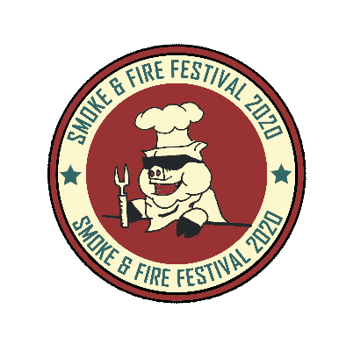
Advertising and Promotion opportunities at the Smoke & Fire Festival for Traders Partners.
(Smoke & Fire Festival Advertising and Brand awareness at the festival)
We took the decision in collaboration with our charity partner to enclose the festival two years ago and now charge a small entry fee of just £5 per adult with all kids getting free entry (in aid of the Air Ambulance). A very generous company called Altrad generations Sales & Hire is kindly donating the Heras fence paneling for this year’s event but the cost of transporting it is fairly high. So we are looking to cover the cost of delivery, erecting and collection of these panels by allowing adverting on the perimeter fencing.
Traders who advertised on these panels noticed a marked increase in footfall to their pitch. Each Scrim panel is 3.5m wide x 2.00m high (Heras Fence Panel). This is a great way to get your brand across to all visitors to the festival and those who are visiting the park. (Opportunities to see: 70k over the weekend- plus general park visitors, your scrim will be on display for a whole 5days Weds-Sun)Branded / Printed with your logo /artwork for only £130 per panel.
Artwork to be supplied by you to our specification your artwork are at least 150 dpi.

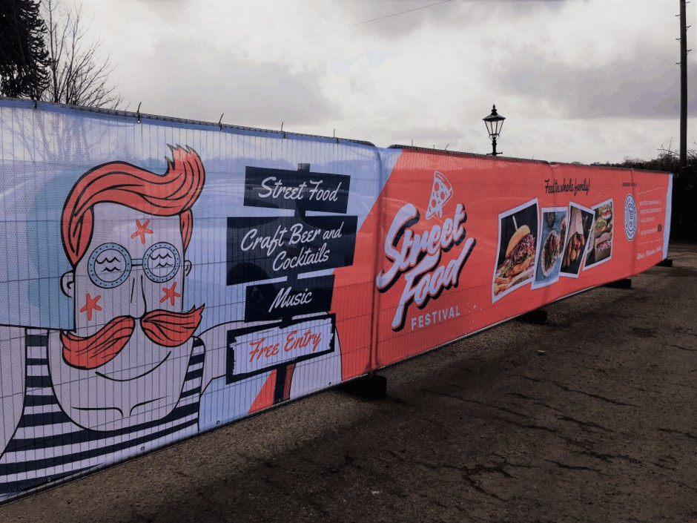

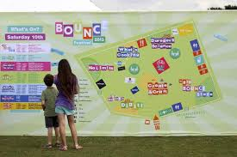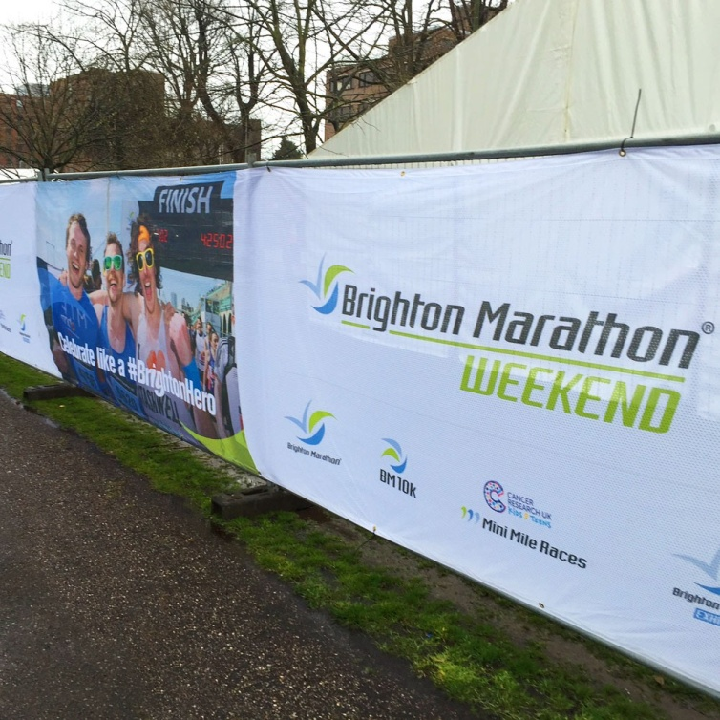

LIMTED ADVERTISING AVIAVALE IN FESTIVAL PROGRAMME
Full Colour Festival Programme (Print Run15k) Sold on a first come basis

All traders will have their name appear in the Programme as part of our commitment to you. But if you want to stand out from the crowd please read on:

The Ad sizes are self-explanatory,
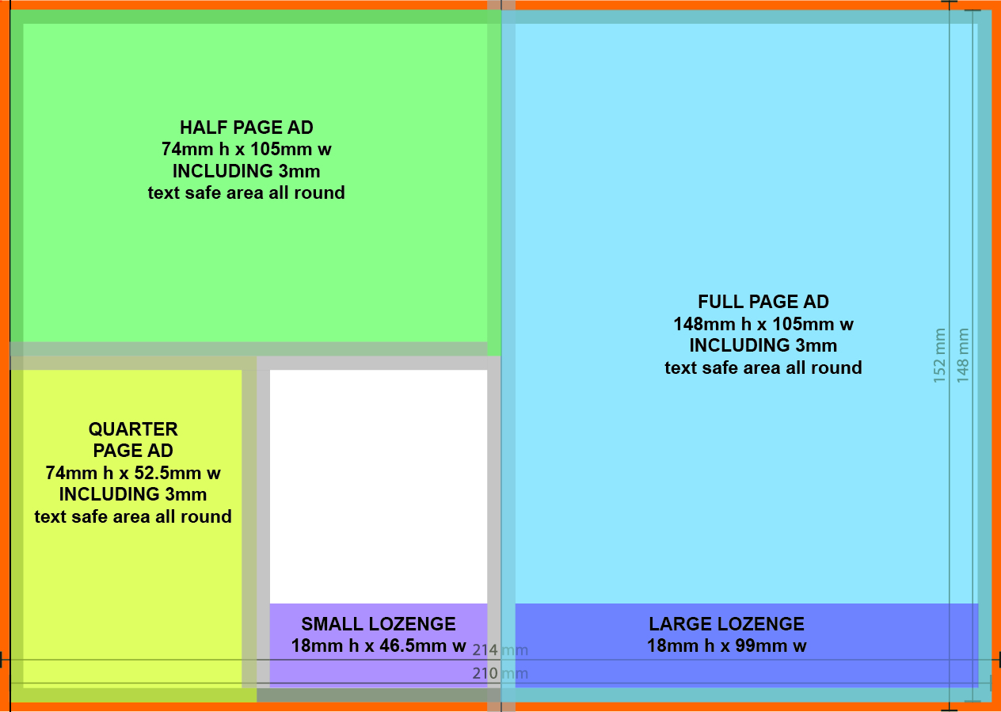

the size given is the overall size, and we RECOMMEND a 3mm text 'safe' area which is included in the total size of the ad.

There are
· Rear cover £400
· Inside Front £300 (Sold)
· Full page, £270
· Half page, £160
· Quarter page, £100
· Large lozenge £ 70
· Small lozenge £ 50

The LOZENGES sit over other content - i.e. they appear at the bottom of an editorial page; All other ads are on pages allocated purely for advertising.
There are 4 PAGES of advertising space INSIDE the magazine EXCLUDING THE FULL-PAGE REAR COVER AND INSIDE FRONT COVER and LOZENGES.
.
Festival Programme Artwork
Advertisers need to supply finished artwork at 300 DPI and exact size, OR we can make ads up for you from your ideas, which we will charge for.
· FULL PAGE: £100
· HALF PAGE: £70
· 1/4 PAGE: £50
· Lozenges £45 (large or small).
If you are interested in advertising at this year’s festival please let us know when booking or call ASAP as we obviously have limited space.
Smoke & Fire Festival 2020
T: 07843 217194
E: Traders@smokeandfirefestival.com
www.smokeandfirefestival.com

